

This property is being sold subject to unconditional purchase premium auction terms and conditions.

Timescales

Immediate exchange of contracts. Completion must take place within 28 days.

Deposit

In order to secure the purchase a buyer will pay a deposit of 5% (subject to a minimum of £3,000) which contributes towards the overall purchase price of the property.

The deposit is non-refundable.

Legal Pack

A legal pack is available for this property. We strongly advise all potential bidders thoroughly read through the legal pack prior to bidding, paying particular attention to the special conditions. If you are unsure of anything contained within the pack, please consult a legal representative.

More Information

For further information please contact our auction department on 0191 239 0812 or email auctions@sarahmains.com
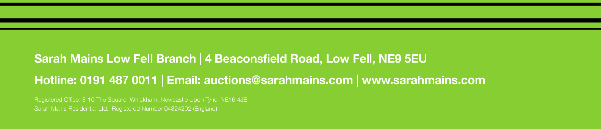

ONLINE AUCTION NOTICE

I hereby acknowledge and confirm the following:

Once placed, my bid cannot be withdrawn and will stand until 2 hours after the auction closes. My bid may be accepted by the seller at any time before the close of the auction. I have read and understood the terms of the auction and my bid is placed accordingly. I have read and understood the legal pack applicable to this property and I understand that I am bound by the special conditions contained within. If my bid is successful at any point from now until up to 2 hours after the auction closes, I shall be bound by the lot terms and conditions as advertised online.

At the point of registration you will be required to insert credit or debit card details as a way of payment towards the deposit and or purchase premium. We will pre-authorise a nominal amount which will be detailed prior to bidding. This amount will only be debited from your account should you be the successful bidder, if you are unsuccessful the agreed amount will be released back to your card within five working days. If you are the successful bidder the agreed amount will be debited at the close of the auction, we will then contact you to confirm if any additional funds are required to cover the deposit and purchase premium. The balance is expected to be paid within the same day as the auction ends.

The auction will continue to run if there is a bid within 10 minutes of the closing time. After 10 minutes without a bid, providing the reserve price has been met, the highest bidder will be successful. If there is another bid within 10 minutes of the last bid, the auction countdown timer will be restarted for another 10 minutes to allow further bidding. This system makes it fairer for all parties involved and prevents last second bidding.

Please bid in good time before the end of the auction, delaying your bid to the last seconds may disadvantage you if your connection slows or you lose internet connectivity. It is the bidder's responsibility to ensure the bid has been lodged with the auctioneer. The auctioneer accepts no responsibility for bids that are not received or are received late, and reserves the right to reject any bid without notice.

